**Presscloud Introduces 'Annie', the first generative AI copywriter**

**PR platform Presscloud unveils 'Annie', an innovative feature that offers users instantaneous enhancements for manually drafted press releases. This AI copywriter evaluates text quality and flags structural, linguistic, and tone-of-voice elements that often influence journalists' decisions regarding publication chances.**

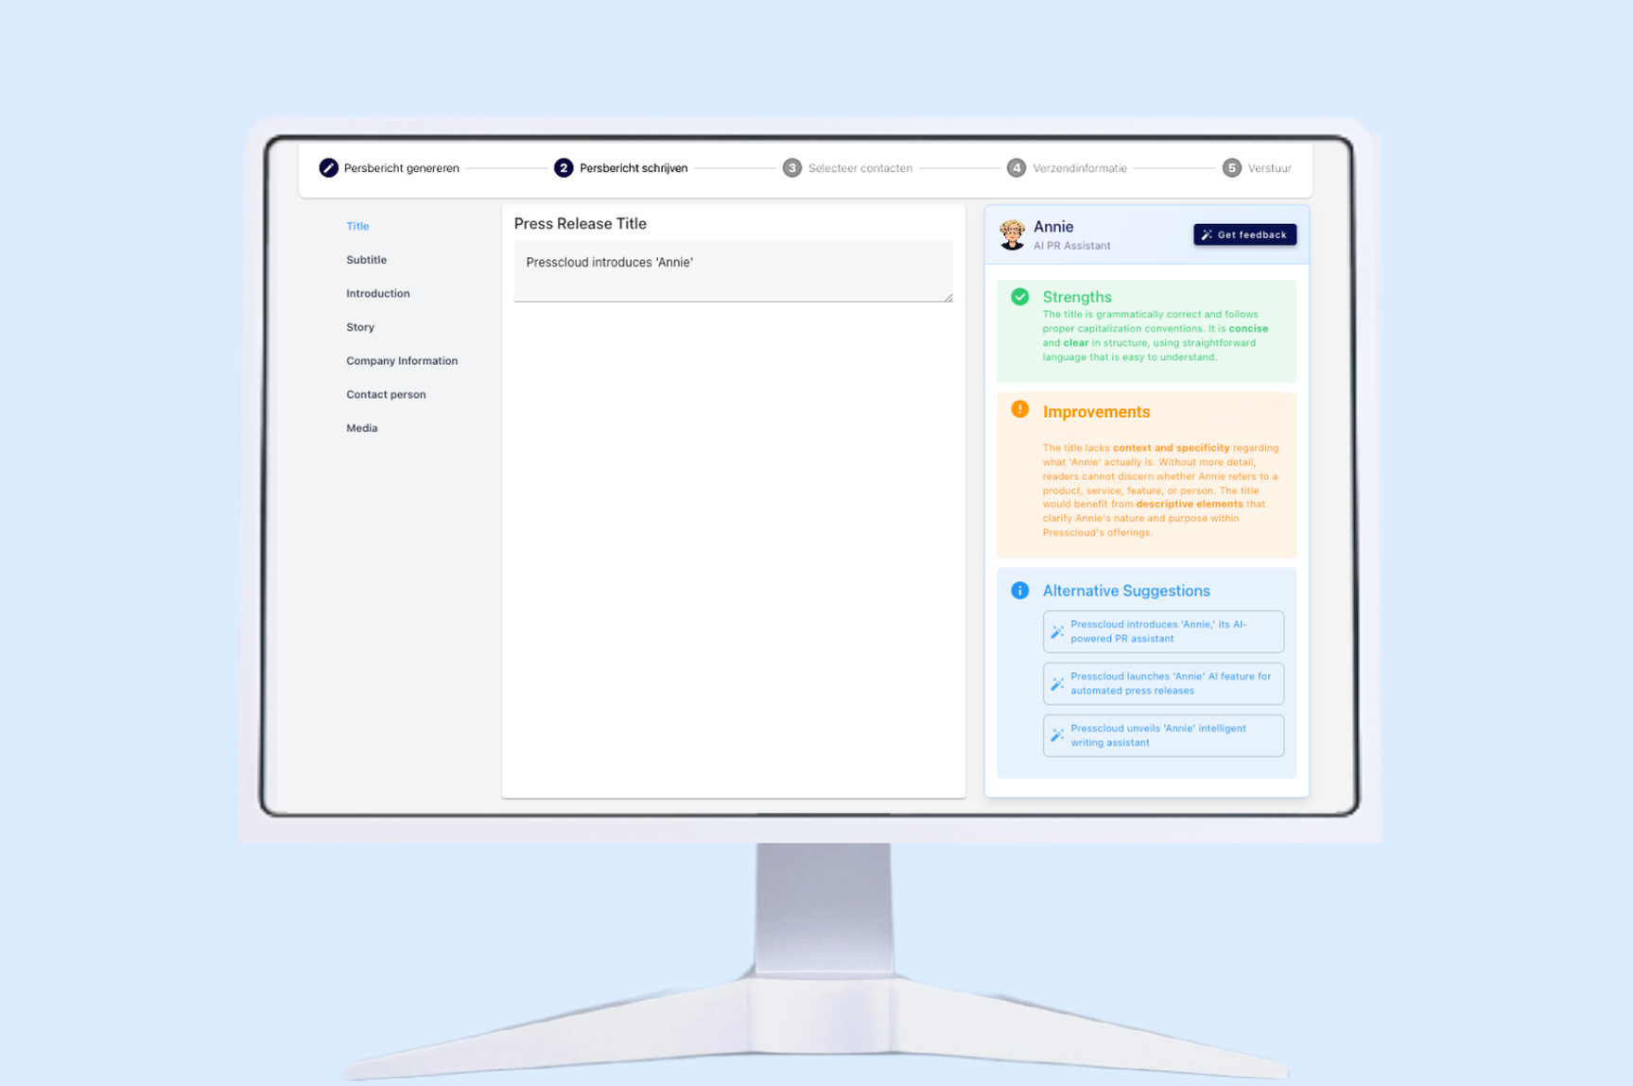

**Quality Control for Manually Created Content**

'Annie' tackles common pitfalls in the PR sector: press releases unfit for publication due to commercial bias, poor structure, or incorrect language usage. Authors often get carried away, resulting in texts overloaded with superlatives and an infomercial-like tone.

“We often see creators of handwritten press releases facing the same stumbling blocks. Annie addresses all these issues head-on,” said Timon Hendriks, spokesperson for Presscloud. “But she doesn’t just pinpoint problems; she also highlights the strengths. This way, authors keep their original message intact, while the statement meets journalists' expectations.”

**AI-Generated Content**

Artificial Intelligence (AI) is no stranger to many. You can ask Large Language Models (LLMs), like ChatGPT or Gemini, to draft a press release. However, a simple prompt often yields a basic result that doesn’t meet the necessary standards for publication.

Presscloud aimed to offer a superior alternative and launched an AI generator in 2023 on its platform, supported by meticulously crafted prompts from years of experience, knowledge, and analysis. Although 'Annie' might seem redundant in this context, she proves invaluable by allowing users to explore text alternatives and gain insight into the choices made by the AI tool during the composition process—beneficial for future campaigns.

**Integration into Existing Platform**

The functionality is immediately available for all users. 'Annie' can be activated with a magic wand-like button next to the text editor. This innovation complements Presscloud’s mission to expedite media visibility for companies, regardless of size, budget, or experience.

**Over: Presscloud**

Presscloud is an all-in-one PR platform that marries traditional PR methodologies with cutting-edge AI technology. The platform empowers businesses to craft compelling narratives and reach the right audience through an extensive media contact database in Europe and the US. Following the dispatch of press releases, Presscloud provides real-time analytics for insights into PR impact.

**Newsroom**

Bekijk het volledige persbericht inclusief meer foto's en video's in onze Newsroom.

[Bekijk het volledige persbericht](https://presscloud.presscloud.ai/pers/presscloud-introduces-annie-the-first-generative-ai-copywriter)

[Bekijk alle voorgaande persberichten](https://presscloud.presscloud.ai)

**Contact informatie**

Naam: Timon Hendriks

E-mail: timon@presscloud.ai

Telefoon: +31 614910859